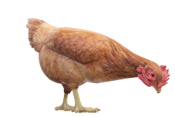

CHICKENS CAN’T

FLY

Shop

Tutorial

Leader board

Start

Settings